





4

2

**+ = + =**



2.



**- = - = - =**

2

1

1

4

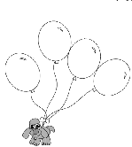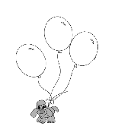

3.

2 + 2 = 3 + 1 = 1 + 3 = 1 + 2 =

4.



4 – 2 = _____ 3 – 2 = _____ 4 – 4 = ______

Emri dhe mbiemri i nxënësit:__________________________